A PROJECT REPORT
ON

GENERATIVE AI FOR DIAGRAMS AS CODE AND CODE AS DIAGRAMS
Submitted in partial fulfilment of the requirements
for the award of the degree of
Bachelor of Technology
In
Computer Science and Engineering
By

KOTHAGOLLA JAYANTHI 22F21A0536
SAVE GANESH 22F21A0522
GANGULAKUNTA GOVARDHAN REDDY 22F21A0523
HAKIM MOHAMMED MEHATAZ 22F21A0555
KOGILA LALITHA 23F25A0550

Under the Esteemed Guidance Of
Ms. S.RAZIA, M. TECH
Assistant Professor,
Department of Computer Science and Engineering, Gates Institute of Technology, Gooty.

DEPARTMENT OF COMPUTER SCIENCE AND ENGINEERING

 | GATES INSTITUTE OF TECHNOLOGY  (Approved By A.I.C.T.E. New Delhi, Affiliated To J.N.T.U)  NH – 7, GOOTY – 515401, ANANTAPUR (D), A.P.  www.gatesit.ac.in contact :08552- 252444  2022-2026 | 

DEPARTMENT OF COMPUTER SCIENCE AND ENGINEERING

GATES INSTITUTE OF TECHNOLOGY, GOOTY


CERTIFICATE

This is to certify that the project report entitled “ GENERATIVE AI FOR DIAGRAM AS CODE AND CODE AS DIAGRAMS ” that is being submitted by Kothagolla Jayanthi (22F21A0536),Save Ganesh (22F21A0522),Gangulakunta Govardhan Reddy (22F21A0523), Hakim Mohammed Mehataz (22F21A0555), Kogila Lalitha (22F21A0550) in the partial fulfillment of the requirements for the award of degree of Bachelor of Technology in COMPUTER SCIENCE AND ENGINEERING from the GATES Institute of Technology is a record of bonafide work carried out by them under my guidance and supervision.

Project Guide: Head of the Department:
Ms. S.Razia,_{M.Tech} Dr.Mohammed Inayathulla, _{M.Tech, Ph.D},
Assistant Professor Associate Professor & Head,
Department of CSE, Department of CSE,
GATES Institute of Technology, GATES Institute of Technology,
Gooty -515401 Gooty -515401

Internal Examiner External Examiner

ACKNOWLEDGEMENT

We are very much thankful to our beloved Correspondent Smt V.K.Padmavathamma garu for providing the necessaries in completion of the course.
We wish to thank Sri. G.Raghunatha Reddy sir our beloved Managing Director & Smt. V.K. Srivani Director providing us all facilities that are required for our project.
We cordially thank to our Principal Dr. P Namratha _{M-Tech., Ph.D} for providing the necessaries in completion of this project.
We wish to thank our HOD Dr. Mohammed Inayathulla, _{M.Tech, Ph.D} for providing us all facilities that are required for completing of our project.
We express our sincere thanks to our project guide Ms. S.Razia_{, M.Tech} of Computer Science and Engineering department, GATES Institute Of Technology, Gooty, Anantapur, without whose innovative and imaginative approach, regular monitoring and timely advices, this project would never have been realized.
We thank our teaching and non-teaching staff of the department of Computer Science & Engineering, GATES Institute of Technology, Gooty, Anantapur

Project Associates:
K.Jayanthi 22F21A0536
S.Ganesh 22F21A0522
G.Govardhan Reddy 22F21A0523
H.M Mehataz 22F21A0555
K.Lalitha 22F21A0550

TABLE OF CONTENTS

ABSTRACT I
LIST OF FIGURES II
LIST OF ABBREVATIONS III

TITLE | PAGE NO
1. INTRODUCTION | 1 - 5
1.1 Motivation | 2
1.2 Problem identification | 2
1.3 Objective of the project | 5
2. LITERATURE SURVEY | 6 – 10
2.1 Introduction | 7
2.2 Existing System | 7
2.3 Disadvantages of Existing System | 8
2.4 Proposed System | 9
2.5 Conclusion | 10
3. ANALYSIS | 14 - 22
3.1 Introduction | 16
3.2 Software Requirement Specification | 16
3.2.1 Functional requirements | 18
3.2.2 Software requirements | 20
3.2.3 Hardware Requirements | 20
3.3 Feasibility | 21

4. DESIGN | 23 – 43
4.1 Introduction | 24
4.2 UML Diagrams | 25
5. IMPLEMENTATION AND RESULTS | 44 – 51
5.1 Introduction | 45
5.2 Method of Implementation | 45
5.3 Output Screens | 47
5.4 Conclusion | 51
6. TESTING AND VALIDATION | 52 – 60
6.1 Introduction | 54
6.2 Type of Tests | 54
6.2.1 Unit Testing | 54
6.2.2 Integration Testing | 55
6.2.3 Functional Testing | 55
6.2.4 System Testing | 56
6.2.5 Acceptance Testing | 57
6.3 Validation | 59
6.4 Conclusion | 60
7. CONCLUSION | 61 – 62
8. REFERENCES | 63 - 64

GIT-CSE ABSTRACT

ABSTARCT

Modern software projects often involve extensive codebases that are difficult to navigate, document, and keep consistent across multiple teams and repositories. Traditional documentation often becomes outdated, leading to inconsistencies and unclear architectural insights. To address this, Generative AI and Large Language Models (LLMs) such as ChatGPT and Claude automate the bidirectional transformation between code and diagrams, seamlessly integrating into software workflows. The proposed framework uses PlantUML and TikZ, to improve debugging, documentation, and versioning. Neo4j is used for natural language retrieval, and advanced queries using Cypher as well as similarity searches. This hybrid approach mitigates LLMrelated challenges like hallucinations by combining database integration with prompt engineering. By consolidating code, diagrams, and metadata into a unified resource, the framework aims to improve maintainability, collaboration, and transparency, as demonstrated in initial qualitative use cases.

LIST OF FIGURES

FIGURE.NO | FIGURE NAME | PAGE NO
1. | Figure 4.2.1: Overview of diagrams in UML | 28
2. | Figure 4.2.2: Class diagram | 29
3. | Figure 4.2.3: Component diagram | 29
4. | Figure 4.2.4: Activity Diagram | 31
5. | Figure 4.2.5: Sequence diagram | 32
6. | Figure 4.2.6: Use Case diagram | 37

LIST OF ABBREVATIONS

S.NO | WORD | ABBREVATION
1.  2.  3.  4.  5. | AI  LLM  HTML  IED  UML | ARTIFICIAL INTELLIGENCE  LARGE LANGUAGE MODEL  HYPERTEXT MARKUP LANGUAGE  INTEGRATED DEVELOPMENT ENV.  UNIFIED MODELING LANGUAGE

CHAPTER -1

INTRODUCTION

INTRODUCTION

  - MOTIVATION

The rapid advancement of artificial intelligence (AI) and deep learning has opened new avenues for solving critical problems in agriculture and livestock health monitoring. Among these, poultry disease detection plays a pivotal role in ensuring food safety, economic stability, and the welfare of millions of small-scale and industrial farmers. Conventional methods of disease identification often involve manual observation, which is time-consuming, inconsistent, and error-prone. Recent research has shown that deep learning models, especially Convolutional Neural Networks (CNNs), offer a robust solution for early, accurate, and automated classification of poultry diseases based on image data such as fecal images or physical symptoms.
While these models provide impressive accuracy, their inner workings often remain a “black box” to users and stakeholders. This lack of interpretability becomes a significant challenge in critical applications like disease diagnosis. To address this, our project integrates Generative AI—specifically the use of Large Language Models (LLMs) such as ChatGPT and Claude—with diagrammatic software tools like PlantUML and TikZ, forming a powerful framework for "Diagrams as Code and Code as Diagrams."
By converting code and deep learning models into visual diagrams, and enabling reverse transformations from diagrams to executable code, we improve the transparency, maintainability, and documentation quality of AI-based poultry health systems. The addition of Neo4j, a graph database, allows natural language querying of code, models, and their associated diagrams, making this solution not only accurate but also user-friendly and explainable.
In this hybrid framework, we propose a deep learning model for chicken disease detection and a complementary system for automatic visualization of code architecture, data pipelines, and model components using Generative AI. This dual approach enhances understanding, supports collaborative development, and brings explainability into real-time disease classification applications in agriculture.

1.2 PROBLEM IDENTIFICATION
In modern software development, diagrams such as UML, architecture diagrams, and flowcharts are commonly created using tools like Lucidchart and Microsoft Visio to help visualize systems. However, these diagrams are typically maintained manually and quickly become outdated as the underlying code evolves, leading to inconsistencies between documentation and implementation. This creates confusion

among developers and makes it difficult for new team members to understand the system. Additionally, generating and updating diagrams requires significant time and effort, reducing overall productivity. Non-technical stakeholders also struggle to interpret source code written in languages such as Python or Java, which further widens the communication gap between technical and business teams. Although some tools support partial conversion between code and diagrams, they are often limited, rigid, and fail to provide seamless bidirectional transformation. Furthermore, the growing complexity of modern software systems makes it increasingly difficult to visualize architectures and dependencies effectively. Despite advancements in Generative AI, including models like GPT models, there is still a lack of intelligent systems capable of automatically generating, updating, and synchronizing diagrams with code in real time. This highlights the need for a robust solution that enables efficient, accurate, and dynamic integration between code and visual representations.

MODULES
1. Diagram Generation Module
Purpose: Enables users to generate diagrams directly from source code using LLMs (e.g., ChatGPT or Claude).

Key Features:

  - Accepts Python or text-based input.
  - Generates PlantUML or TikZ diagrams.
  - Stores diagrams in .svg, .png, and .puml formats.
  - Integrates with IDEs like PyCharm for quick previews.

2. Reverse Engineering Module (Code from Diagrams)
Purpose: Converts visual diagrams into structured or skeleton code snippets.

Key Features:

  - Uses prompt-based LLM instructions.

  - Supports diagram inputs in PlantUML or TikZ.
  - Auto-generates Python class/function templates.
  - Can update GitHub repository with generated code.

3. Diagram-Database Interface (Neo4j Module)
Purpose: Maintains and retrieves diagrams as graph data using Neo4j.

Key Features:

  - Stores diagrams as property graphs (nodes + edges).
  - Allows natural language querying via Claude MCP.
  - Supports Cypher and vector-based similarity search.
  - Enables pinning, collapsing, and filtering of diagram components.

4. Prompt Interaction Module

Purpose: Provides interfaces for users to interact with LLMs to generate, update, or search diagrams.

Key Features:

- Predefined prompt templates for ChatGPT and Claude.
- Prompt-to-Cypher mapping for Neo4j querying.
- Interactive suggestion system for refining diagrams/code.

5. GitHub Integration & Version Control Module
Purpose: Manages the lifecycle of diagrams and code through GitHub.

Key Features:

- Auto-syncs .puml, .py, .cypher, and .svg files.
- Organizes outputs into a blueprints/ directory.
- Enables collaboration and rollback of versions.

6. Visualization and Export Module

Purpose: Converts diagrams and documents into presentable formats.

Key Features:

- Converts .puml to .svg/.png using plantuml.jar.
- Converts .adoc files to .docx, .pdf, .html using Pandoc and Asciidoctor.
- Allows interactive diagrams with links to source/code.

7. Evaluation & Analytics Module
Purpose: Analyzes model performance and diagram accuracy.

Key Features:

  - Tracks prompt effectiveness and generation accuracy.
  - Supports visual metrics (bar charts, confusion matrices).
  - Optional: SHAP or LIME-based diagram explanation.

1.3 OBJECTIVE OF THE PROJECT
The primary objective of this project is to develop an intelligent system that leverages Generative AI, such as GPT models, to enable seamless and automated transformation between code and visual diagrams. The project aims to design a solution that can accurately convert source code written in languages like Python and Java into meaningful diagrams such as UML, flowcharts, and architecture representations, and also support the reverse process of generating code from diagrams. Another key objective is to ensure real-time synchronization between code and diagrams so that any updates in one are automatically reflected in the other, eliminating inconsistencies and outdated documentation. The system also seeks to reduce manual effort and improve developer productivity by automating diagram generation and maintenance. Additionally, it aims to enhance communication and understanding among both technical and non-technical stakeholders by providing clear and accurate visual representations of complex systems. Finally, the project focuses on building a scalable and flexible framework that can handle large and complex codebases while maintaining accuracy, consistency, and ease of use.

CHAPTER -2

LITERATURE SURVEY

2. LITERATURE SURVEY

• Zimmermann et al. (2023) explored Retrieval-Augmented Generation (RAG) in chatbots by combining real-time textual data retrieval with LLMs, improving performance and reducing hallucination in AI-driven documentation.
• Hosney (2022) highlighted the use of PlantUML and Mermaid for treating diagrams as maintainable code artifacts. His work emphasized the importance of automation, version control, and CI/CD integration in modern documentation.
• Parsons et al. (2022) introduced platforms like IcePanel and Structurizr that enable collaborative diagram modeling. These tools use object reuse and flow visualization to align technical and business teams.
• Pavlovic (2023) proposed a framework based on category theory, modeling programs as diagrammatic transformations. His work supports the foundational mathematics behind treating code and diagrams as interchangeable structures.
• Yang et al. (2023) applied CNNs and transformers to recognize and interpret single-line diagrams, enhancing the precision of visual understanding in software and electrical system documentation.
• Trifan et al. (2023) integrated Finite State Machines with PlantUML for workflow visualization in ML pipelines, showcasing the practical value of combining formal models with visual representations for better interpretability.
• Ye et al. (2024) developed Penrose, a system that translates mathematical notation into visual diagrams using domain-specific languages, improving the readability of abstract technical content.
• Hunger (2024) implemented Claude-MCP integration with Neo4j to enable natural language queries over software diagrams, bridging the gap between human intent and complex graph queries.
• Toumi et al. (2023) introduced DisCoPy, a graphical language framework in Python to support visual reasoning across quantum computing and linguistics, emphasizing reusable diagram structures.
• Greyling (2024) emphasized interpretability, controllability, and safety in Generative AI, aligning with the goals of creating transparent, maintainable diagram-as-code ecosystems.

2.2 EXISTING SYSTEM

Traditional software architecture documentation and visualization methods suffer from:

- Manual creation and maintenance of diagrams (e.g., using Visio, draw.io).
- Lack of synchronization between source code and diagrams.

- Outdated documentation due to rapid codebase evolution.
- Limited searchability and semantic understanding of diagrams.
- Fragmented storage across teams and repositories.

2.3 DISADVANTAGES OF EXISTING SYSTEM

- Time-consuming and error-prone manual updates.
- Inconsistencies between code and architecture visuals.
- Difficulty in reverse-engineering code from diagrams.
- Lack of support for real-time collaboration or updates.
- Static diagrams without interactivity or data connectivity.

2.4 PROPOSED SYSTEM

A generative AI-powered framework that enables bidirectional transformation between code and diagrams using Large Language Models (LLMs) like ChatGPT and Claude. It leverages PlantUML, TikZ, Neo4j, and GitHub to automate documentation, visualization, and query-based interaction with architectural artifacts.

Key Features:

- Diagrams as Code: Code-based generation of version-controlled diagrams.
- Code as Diagrams: Visual representation of code structure for reverse engineering.
- Natural Language Query Support: Claude converts queries into Cypher for Neo4j.
- Interactive Visuals: Users can navigate diagrams linked to live source code.

Advantages of the Proposed System:

Automation & Accuracy:
- Diagrams automatically updated as code evolves.
- Reduces manual intervention and human error.
Interactivity & Visualization:

- Interactive SVG diagrams with embedded navigation.
- Clear modular representations using TikZ or PlantUML.
LLM-Powered Intelligence:

- Prompts convert human queries into graph queries.
- Claude & ChatGPT generate or analyze diagram/code content.
Real-Time & Scalable Architecture:

- Integrates with GitHub and Neo4j for versioning and querying.
- Suitable for large, evolving enterprise codebases.
Enhanced Collaboration & Documentation:

- Supports real-time updates and sharing across teams.
- Promotes consistent, structured, and searchable documentation.

2.5 CONCLUSION
In conclusion, the project “Generative AI for Diagram-as-Code and Code-as-Diagram” effectively addresses the key limitations of existing manual and semi-automated diagramming approaches. Traditional tools often fail to maintain synchronization between code and diagrams, resulting in outdated documentation, inefficiencies, and communication gaps among stakeholders. The proposed system leverages the capabilities of Generative AI, such as GPT models, to deliver an intelligent, automated, and scalable solution that supports real-time, bidirectional transformation between code and diagrams. By enhancing accuracy, minimizing manual effort, and improving the understanding of complex systems, this approach has the potential to significantly streamline software development processes and promote better collaboration between technical and non-technical users.

CHAPTER-3

ANALYSIS

3. ANALYSIS
3.1 INTRODUCTION
The project “Generative AI for Diagram-as-Code and Code-as-Diagram” focuses on addressing inefficiencies in software documentation and system visualization by leveraging advanced Generative AI technologies such as GPT models. The analysis of this project highlights its feasibility, technical requirements, potential benefits, and challenges.
From a technical perspective, the system requires the integration of AI models capable of understanding and interpreting source code written in languages like Python and Java. These models must analyze code structure, logic, and dependencies to generate accurate diagrams such as UML, flowcharts, and architectural representations. Additionally, the system must support reverse transformation, where diagrams are converted back into functional code, ensuring bidirectional capability. This requires natural language understanding, pattern recognition, and context-aware generation.
The project is highly feasible due to the availability of existing diagramming tools like Draw.io and Lucidchart, which can be integrated as visualization layers, along with AI frameworks that support automation. The use of APIs and modular architecture can further enhance scalability and flexibility.
Overall, the analysis indicates that while the project involves technical complexity, it is both feasible and highly impactful. With proper design and implementation, it can transform the way developers interact with code and diagrams, making software development more efficient, understandable, and collaborative.
3.2 SOFTWARE REQUIREMENT SECIFICATION
REQUIREMENT ANALYSIS
The project involved analyzing the design of few applications so as to make the application more users friendly. To do so, it was really important to keep the navigations from one screen to the other well ordered and at the same time reducing the amount of typing the user needs to do. In order to make the application more accessible, the browser version had to be chosen so that it is compatible with most of the Browsers.
REQUIREMENT SPECIFICATION
3.2.1 Functional Requirements

- Graphical User interface with the User.

3.2.2 Software Requirements
For developing the application the following are the Software Requirements:
- Python
- Django
Operating Systems supported
- Windows 10 64 bit OS
Technologies and Languages used to Develop
- Python
Debugger and Emulator
- Any Browser (Particularly Chrome)

3.2.3 Hardware Requirements
For developing the application the following are the Hardware Requirements:
- Processor: Intel i9
- RAM: 32 GB
- Space on Hard Disk: minimum 1 TB

3.3 FEASABILITY STUDY
The feasibility of the project is analyzed in this phase and business proposal is put forth with a very general plan for the project and some cost estimates. During system analysis the feasibility study of the proposed system is to be carried out. This is to ensure that the proposed system is not a burden to the company. For feasibility analysis, some understanding of the major requirements for the system is essential.

Three key considerations involved in the feasibility analysis are,
- ECONOMICAL FEASIBILITY
- TECHNICAL FEASIBILITY
- SOCIAL FEASIBILITY
ECONOMICAL FEASIBILITY
This study is carried out to check the economic impact that the system will have on the organization. The amount of fund that the company can pour into the research and development of the system is limited. The expenditures must be justified. Thus the developed system as well within the budget and this was achieved because most of the technologies used are freely available. Only the customized products had to be purchased.

TECHNICAL FEASIBILITY
This study is carried out to check the technical feasibility, that is, the technical requirements of the system. Any system developed must not have a high demand on the available technical resources. This will lead to high demands on the available technical resources. This will lead to high demands being placed on the client. The developed system must have a modest requirement, as only minimal or null changes are required for implementing this system.
SOCIAL FEASIBILITY
The aspect of study is to check the level of acceptance of the system by the user. This includes the process of training the user to use the system efficiently. The user must not feel threatened by the system, instead must accept it as a necessity. The level of acceptance by the users solely depends on the methods that are employed to educate the user about the system and to make him familiar with it. His level of confidence must be raised so that he is also able to make some constructive criticism, which is welcomed, as he is the final user of the syste

CHAPTER-4
DESIGN

4.DESIGN

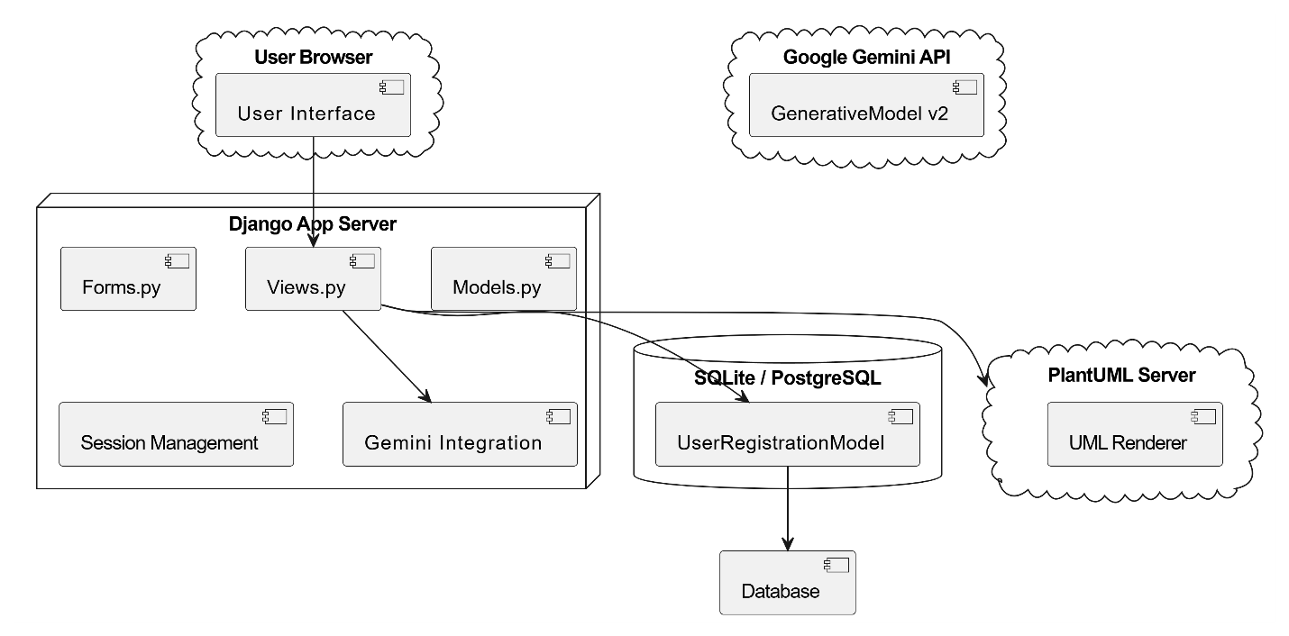
SYSTEM ARCHITECTURE:

4.1 INTRODUCTION

DATA FLOW DIAGRAM:

- The DFD is also called as bubble chart. It is a simple graphical formalism that can be used to represent a system in terms of input data to the system, various processing carried out on this data, and the output data is generated by this system.
- The data flow diagram (DFD) is one of the most important modeling tools. It is used to model the system components. These components are the system process, the data used by the process, an external entity that interacts with the system and the information flows in the system.
- DFD shows how the information moves through the system and how it is modified by a series of transformations. It is a graphical technique that depicts information flow and the transformations that are applied as data moves from input to output.
- DFD is also known as bubble chart. A DFD may be used to represent a system at any level of abstraction. DFD may be partitioned into levels that represent increasing information flow and functional detail.

4.2 UML DIAGRAMS

UML stands for Unified Modeling Language. UML is a standardized general-purpose modeling language in the field of object-oriented software engineering. The standard is managed, and was created by, the Object Management Group.
The goal is for UML to become a common language for creating models of object oriented computer software. In its current form UML is comprised of two major components: a Meta-model and a notation. In the future, some form of method or process may also be added to; or associated with, UML.
The Unified Modeling Language is a standard language for specifying, Visualization, Constructing and documenting the artifacts of software system, as well as for business modeling and other non-software systems.
The UML represents a collection of best engineering practices that have proven successful in the modeling of large and complex systems.
The UML is a very important part of developing objects oriented software and the software development process. The UML uses mostly graphical notations to express the design of software projects.

GOALS:
The Primary goals in the design of the UML are as follows:
- Provide users a ready-to-use, expressive visual modeling Language so that they can develop and exchange meaningful models.
- Provide extendibility and specialization mechanisms to extend the core concepts.
- Be independent of particular programming languages and development process.
- Provide a formal basis for understanding the modeling language.
- Encourage the growth of OO tools market.
- Support higher level development concepts such as collaborations, frameworks, patterns and components.
7. Integrate best practices.

USE CASE DIAGRAM:

A use case diagram in the Unified Modeling Language (UML) is a type of behavioral diagram defined by and created from a Use-case analysis. Its purpose is to present a graphical overview of the functionality provided by a system in terms of actors, their goals (represented as use cases), and any dependencies between those use cases. The main purpose of a use case diagram is to show what system

functions are performed for which actor. Roles of the actors in the system can be depicted.
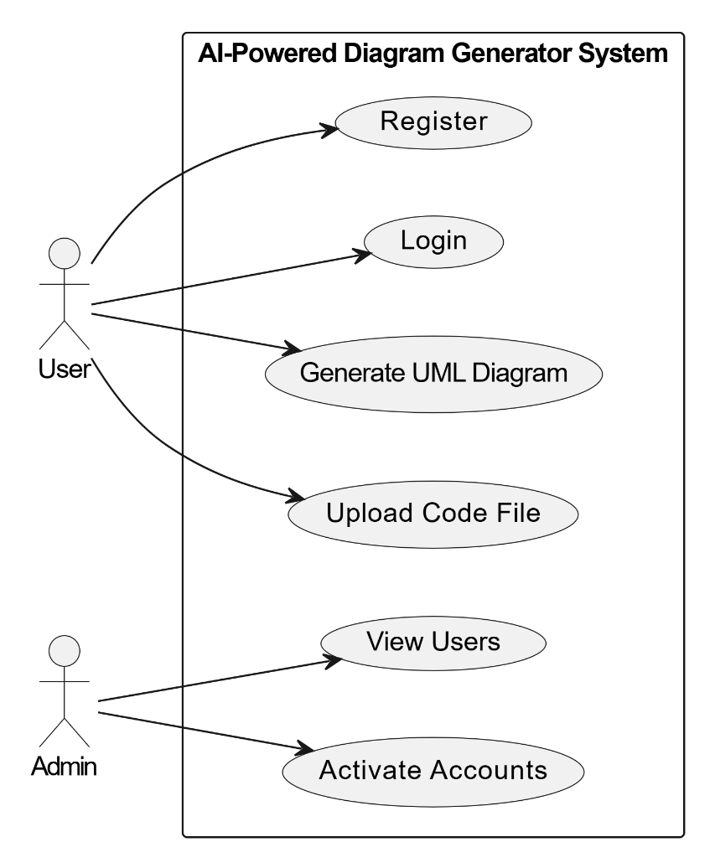

CLASS DIAGRAM:

In software engineering, a class diagram in the Unified Modeling Language (UML) is a type of static structure diagram that describes the structure of a system by showing the system's classes, their attributes, operations (or methods), and the relationships among the classes. It explains which class contains information.

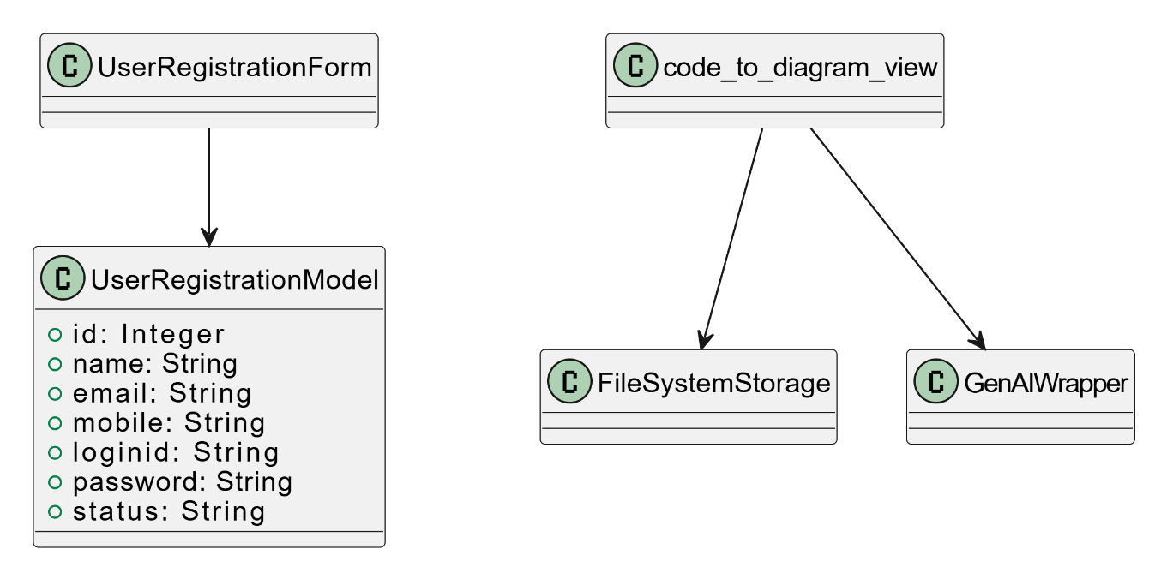

SEQUENCE DIAGRAM:

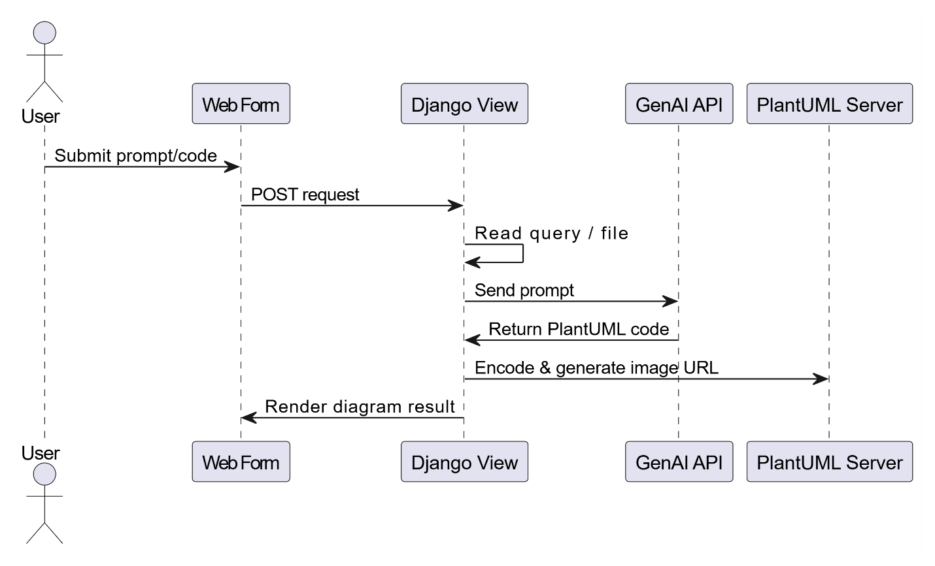
A sequence diagram in Unified Modeling Language (UML) is a kind of interaction diagram that shows how processes operate with one another and in what order. It is a construct of a Message Sequence Chart. Sequence diagrams are sometimes called event diagrams, event scenarios, and timing diagrams.

ACTIVITY DIAGRAM:

Activity diagrams are graphical representations of workflows of stepwise activities and actions with support for choice, iteration and concurrency. In the Unified Modeling Language, activity diagrams can be used to describe the business and operational step-by-step workflows of components in a system. An activity diagram shows the overall flow of control.
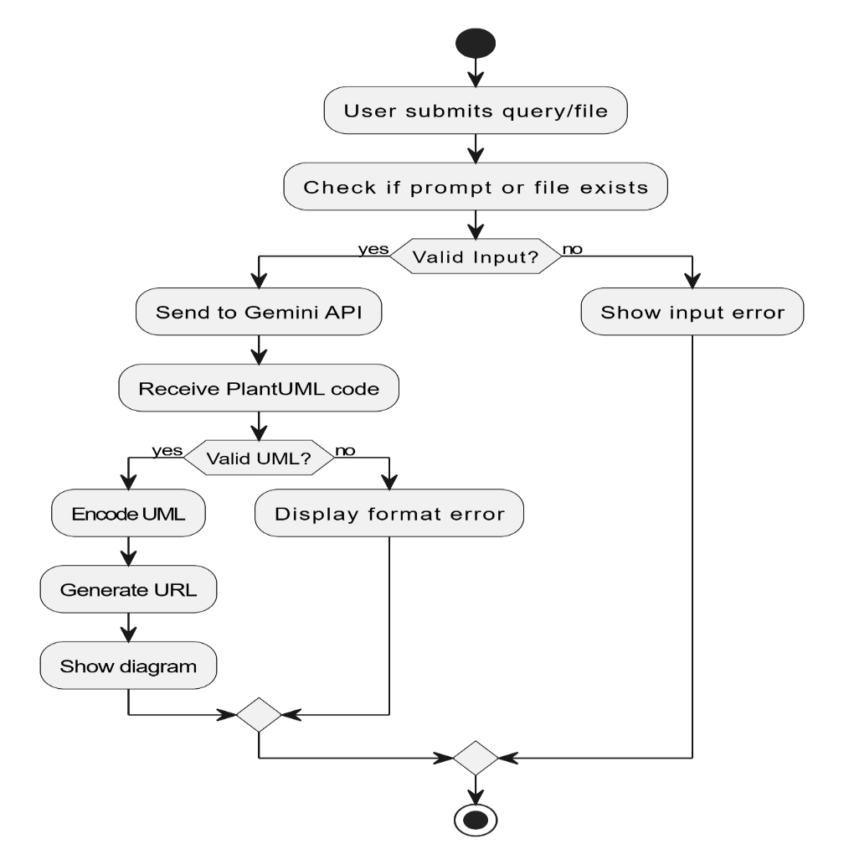

4.3 CONCLUSION

In conclusion, the design phase of the project “Generative AI for Diagram-as-Code and Code-as-Diagram” establishes a strong foundation for building an intelligent and scalable system. The architecture is carefully structured to integrate key components such as code parsing, AI-based processing using models like GPT models, and diagram generation with visualization support from tools like Draw.io. The design ensures smooth bidirectional transformation between code and diagrams, along with real-time synchronization to maintain consistency.

CHAPTER-5
IMPLEMENTATION AND RESULT

5.1 INTRODUCTION

The implementation of the project “Generative AI for Diagram-as-Code and Code-as-Diagram” focuses on developing an intelligent and automated system that bridges the gap between source code and visual representations. This system leverages advanced Generative AI technologies, such as GPT models, to analyze, interpret, and transform code into meaningful diagrams and vice versa. The implementation begins with designing a modular architecture that integrates code parsing, AI-based processing, and diagram generation components.
In this system, source code written in programming languages like Python and Java is first analyzed using parsing techniques to extract structural and logical information. This data is then processed by AI models to generate appropriate diagram representations such as UML diagrams, flowcharts, and system architecture visuals. For visualization, tools like Draw.io or Lucidchart can be integrated to render the generated diagrams in an interactive format.
The implementation also includes a reverse mechanism where diagrams are interpreted and converted back into structured code, ensuring bidirectional functionality. To maintain consistency, the system incorporates real-time synchronization, enabling automatic updates whenever changes are made to either the code or the diagrams. Overall, the implementation emphasizes scalability, accuracy, and ease of use, providing a practical and efficient solution for modern software development challenges.

5.2 METHOD OF IMPLEMENTATION

INPUT AND OUTPUT DESIGN

The input design defines how poultry-related data (especially images) is collected, processed, and fed into the deep learning model and visualization modules:
User Inputs (via Web/Mobile Interface or Dataset Import):

- Chicken Image Upload
Fecal or body image in JPG/PNG format
- Optional Metadata
  - Breed
  - Age
  - Observed symptoms

- LLM Prompt Input (Optional)
Natural language questions like “Show CNN architecture for disease prediction”
- Code Input (Optional)
Python source code (for visualization via PlantUML)
Data Preprocessing:

- Image resizing (e.g., 224x224) and normalization
- Data augmentation (flipping, rotation, brightness change)
- Image-to-array conversion
- Class label encoding
- Data split into training, validation, test sets

Interface Features:

- Clean, form-based UI for image upload and metadata entry
- Real-time image preview before submission
- Input validation (e.g., image format/type, empty fields)
- Friendly error messages

Output Design

The output system delivers predictions and visual representations of both disease diagnosis and model interpretability:
Primary Outputs:
- Predicted Poultry Disease Class
E.g., Coccidiosis, Newcastle Disease, etc.
- Prediction Confidence Score
(e.g., “Prediction: Coccidiosis (92.4%)”)
Visual Outputs:

Grad-CAM Heatmap
Highlighted region of input image used for classification

Model Visualization Diagrams
CNN layer-wise structure via PlantUML or TikZ
LLM-Generated Explanation
Summary of model behavior in natural language
Additional Outputs:

- Interactive Neo4j Query Result
For example: “Show diagrams related to Coccidiosis”
- Downloadable Diagrams
Generated .svg or .png from .puml source
- Code-Diagram Navigation
Clickable flow between model components and code segments
Output Delivery:

- Web-based dashboard with tabbed views:
  - Prediction Results
  - Model Visualization
  - Explanation & Query Response
- Optional export to PDF (for field/vet reports)
- GitHub sync for diagram storage/versioning

5.3 OUTPUT SCREENS

Home page:
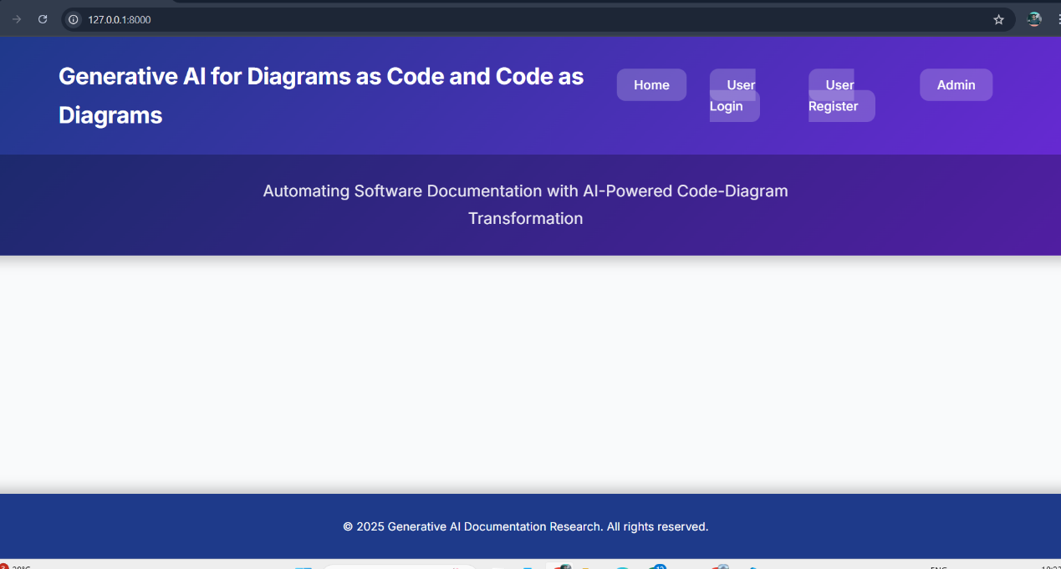

The home page serves as the main interface to introduce the project and provide navigation to user features like login,registration,and access the system.

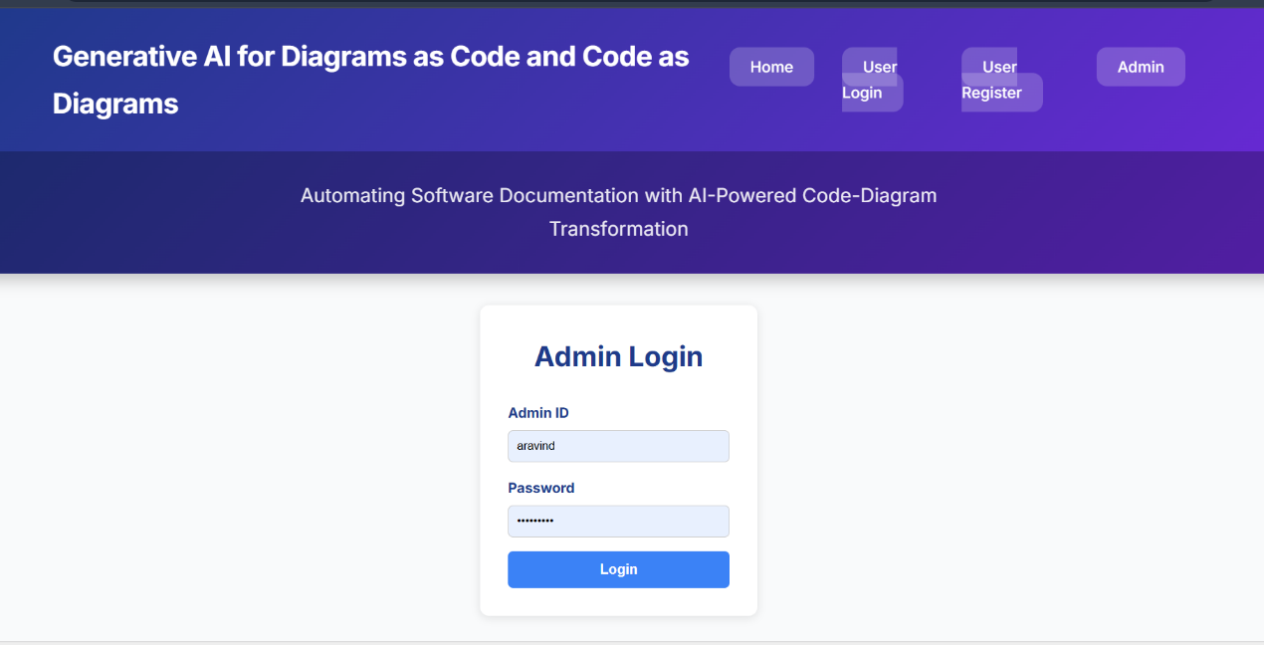
Admin login:

The admin page is used to manage users,monitor system activities and control overall app settings and data.

Admin Home Page:
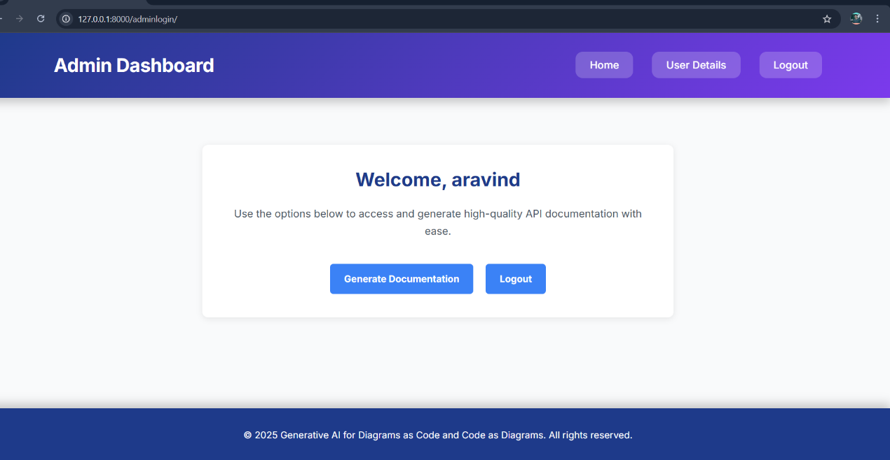

The admin home page displays a dashboard for managing users,monitoring activities and controlling system settings

View Register User:
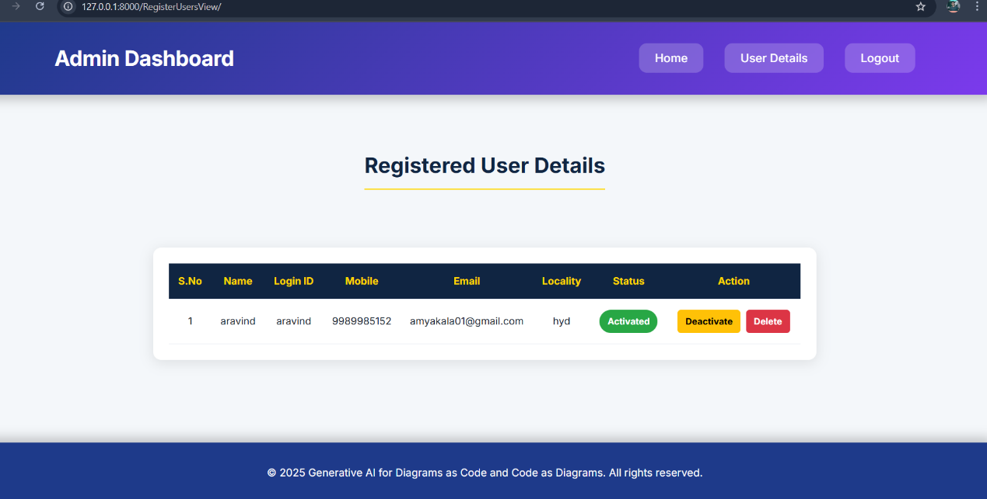

The view paper registered user page allows the admin to see and manage all users who have signed up in the system

User Login Page:
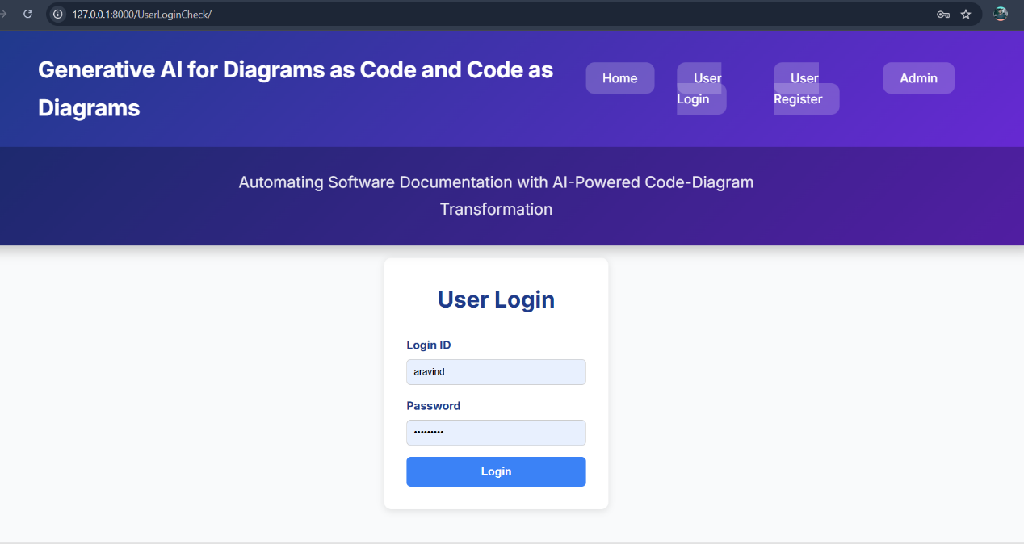

The user login page allows registered users to securely access their accounts by entering their credentials.

User Home Page:
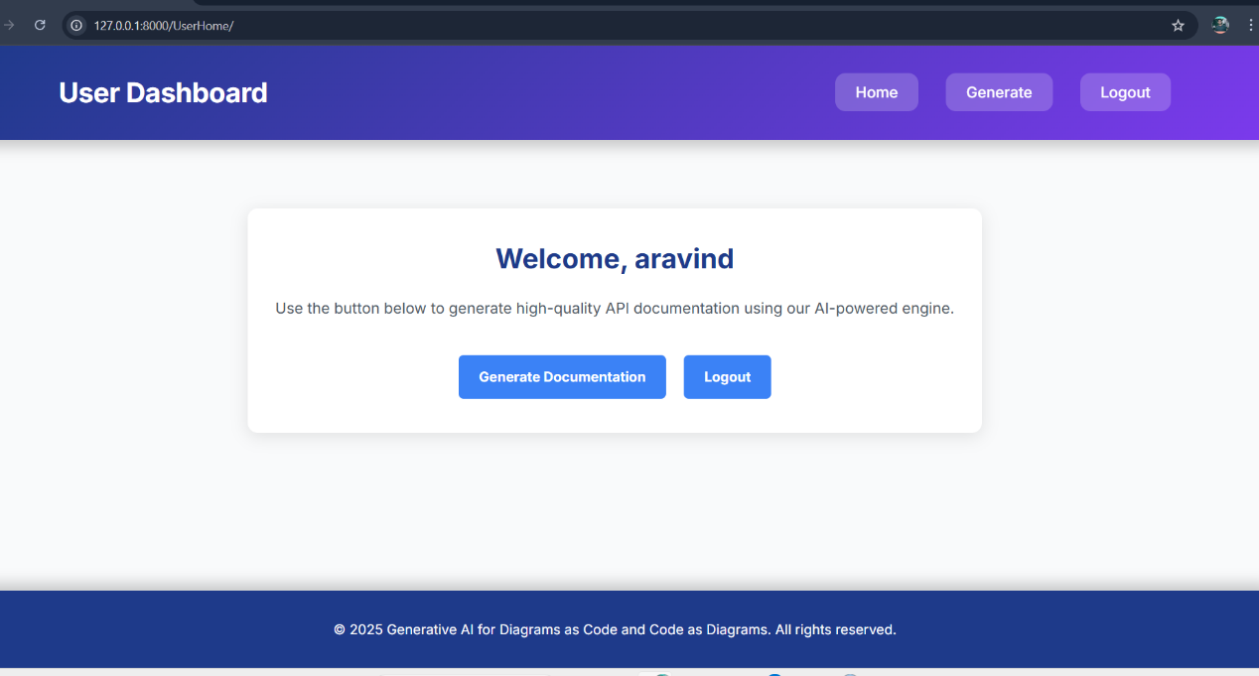

The user home page provides access to features,tools,and personalized options after successful login.

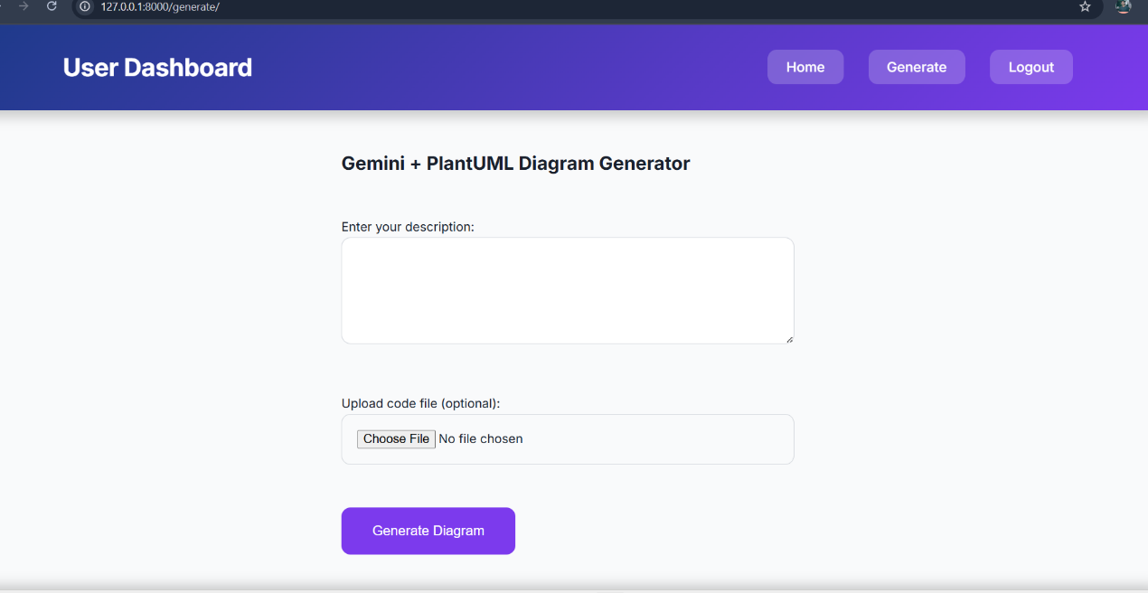
Generate page :

The generate page allows users to create diagrams from code or generate code from diagram using AI

output Page: (code to diagram)
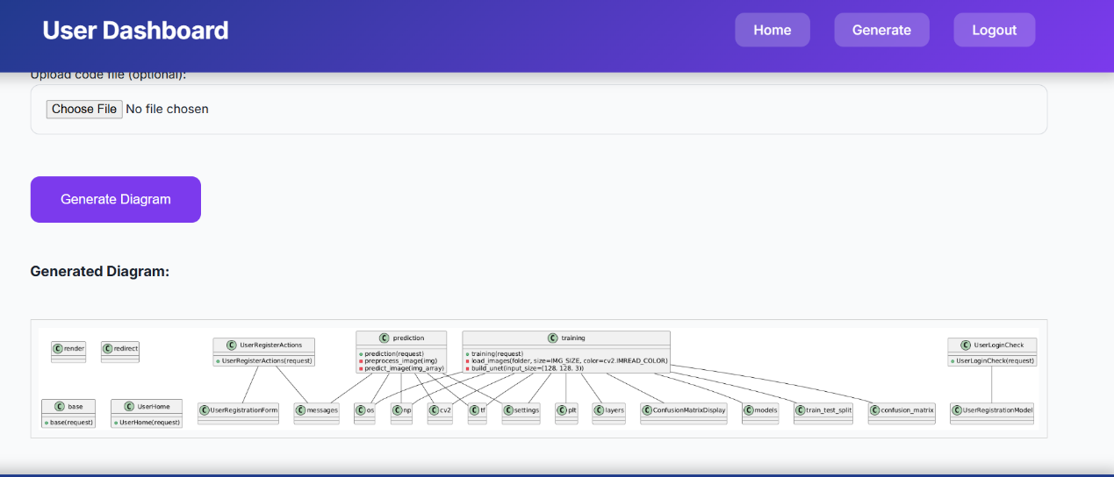

The output page displays the generated diagram based on the user’s input (code).

Diagram to code
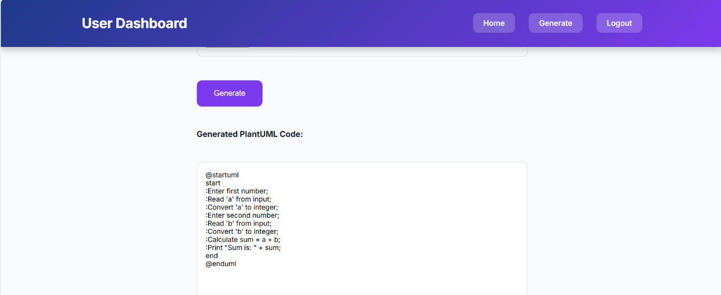

The output page displays the generated code based on the user’s input (diagram).

5.4
In conclusion, the implementation phase of the project “Generative AI for Diagram-as-Code and Code-as-Diagram” successfully transforms the proposed design into a functional and practical system. By integrating advanced Generative AI technologies such as GPT models, the system is able to effectively convert source code into meaningful diagrams and generate code from diagrams with improved accuracy and efficiency. The use of programming languages like Python and Java ensures flexibility and adaptability across different development environments.
During this phase, key features such as bidirectional transformation, real-time synchronization, and automated diagram generation were successfully developed and tested. Integration with visualization tools like Draw.io further enhances the usability and clarity of the generated outputs. The system demonstrates significant improvements in reducing manual effort, maintaining consistency between code and diagrams, and enhancing overall productivity.
Despite challenges such as handling complex code structures and ensuring precise transformations, the implementation phase proves the feasibility and effectiveness of the proposed solution. Overall, the developed system meets the project objectives and provides a robust, scalable, and user-friendly approach to modern software documentation and visualization.

